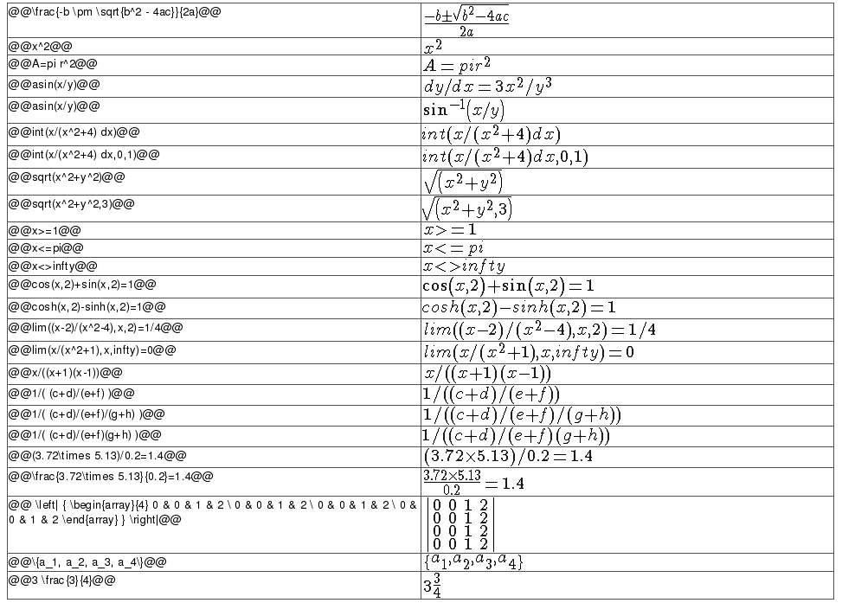

Di sini saya akan lebih sering menggunakan yang pertama, yaitu $#latex kode$, karena lebih simple, maksudnya, di akhirannya hanya menggunakan tanda $ dolar saja. Tidak panjang-panjang

Ingat!! Hapus tanda # sebelum kata latex

***Penulisan Dasar : Subscript, Superscript, Akar Pangkat, Pecahan, dan Sejenisnya***

|  |  |
| --- | --- |
| $#latex a-b+c=d$ | a-b+c=d |
| $#latex a \times b=c$ | a \times b=c |
| $#latex a:b=c$ | a:b=c |
| $#latex \frac{a}{b} =c$ | \frac{a}{b} =c |
| $#latex a^b$ | a^b |
| $#latex a^{b+c}$ | a^{b+c} |
| $#latex a\_b$ | a_b |
| $#latex a\_{b+1}$ | a_{b+1} |
| $#latex a^b\_c$ | a^b_c |
| $#latex a^{b+1}\_{c+1}$ | a^{b+1}_{c+1} |
|  |  |
| $#latex \sqrt{a}$ | \sqrt{a} |
| $#latex \sqrt{3}{a}$ | \sqrt{3}{a} |
| $#latex \sqrt{ \frac{a^2}{3b^3+1}}$ | \sqrt{ \frac{a^2}{3b^3+1}} |
|  |  |
| $#latex \int \, \iiint \, \oint$ | \int \, \iiint \, \oint |
| $#latex \lim\_{n \to \infty} \frac{1}{n}=0$ | \lim_{n \to \infty} \frac{1}{n}=0 |
| $#latex \int^b\_a x^2 \, dx$ | \int^b_a x^2 \, dx |
| $#latex \sum^{\infty}\_{n=1} \frac{1}{n}$ | \sum^{\infty}_{n=1} \frac{1}{n} |
| $#latex \lim \limits\_{n \to \infty} \frac{1}{n}=0$ | \lim \limits_{n \to \infty} \frac{1}{n}=0 |
| $#latex \int \limits^b\_a x^2 \, dx$ | \int \limits^b_a x^2 \, dx |
| $#latex \sum \limits^{\infty}\_{n=1} \frac{1}{n}$ | \sum \limits^{\infty}_{n=1} \frac{1}{n} |
|  |  |
| $#latex (a)$ | (a) |
| $#latex [a]$ | [a] |
| $#latex \{ a \}$ | \{ a \} |
| $#latex |a|$ | |a| |
| $#latex \{ a \}$ | \{ a \} |
| $#latex [\frac{a}{b}]$ | [\frac{a}{b}] |
| $#latex \{ \frac{a}{b} \}$ | \{ \frac{a}{b} \} |
| $#latex \left ( \frac{a}{b} \right )$ | \left ( \frac{a}{b} \right ) |
| $#latex \left [ \frac{a}{b} \right ]$ | \left [ \frac{a}{b} \right ] |
| $#latex \left \lbrace \frac{a}{b} \right \rbrace$ | \left \lbrace \frac{a}{b} \right \rbrace |
| $#latex \left \langle \frac{a}{b} \right \rangle$ | \left \langle \frac{a}{b} \right \rangle |
| $#latex \left \vert \frac{a}{b} \right \vert$ | \left \vert \frac{a}{b} \right \vert |
| $#latex \left \Vert \frac{a}{b} \right \Vert$ | \left \Vert \frac{a}{b} \right \Vert |
| $#latex \left \lfloor \frac{a}{b} \right \rfloor$ | \left \lfloor \frac{a}{b} \right \rfloor |
| $#latex \left \lceil \frac{a}{b} \right \rceil$ | \left \lceil \frac{a}{b} \right \rceil |
| $#latex \downarrow$ | \downarrow |
| $#latex \uparrow$ | \uparrow |
| $#latex \updownarrow$ | \updownarrow |

Ingat!! Hapus tanda # sebelum kata latex

***Penulisan Simbol atau Tanda Hubung atau Sejenisnya***

|  |  |
| --- | --- |
| $#latex \bar{A}$ | \bar{A} |
| $#latex \hat{a}$ | \hat{a} |
| $#latex \vec{c}$ | \vec{c} |
| $#latex \overline{xy}$ | \overline{xy} |
| $#latex \widehat{xy}$ | \widehat{xy} |
| $#latex \overrightarrow{xy}$ | \overrightarrow{xy} |
| $#latex \overleftarrow{xy}$ | \overleftarrow{xy} |
| $#latex \underline{xy}$ | \underline{xy} |
| $#latex \overset{a}{b}$ | \overset{a}{b} |
| $#latex \underset{a}{b}$ | \underset{a}{b} |
| $#latex {a \atop b}$ | {a \atop b} |
| $#latex {a \choose b}$ | {a \choose b} |
| $#latex \overbrace {a+a+ \cdots+a}^{\mbox{n kali}}$ | \overbrace {a+a+ \cdots+a}^{\mbox{n kali}} |
| $#latex \underbrace{a+a+ \cdots +a}\_{\mbox{n kali}}$ | \underbrace{a+a+ \cdots +a}_{\mbox{n kali}} |
| $#latex \begin{cases} n, & \mbox{if} n\mbox{ is even} \\ 2n, & \mbox{if} n\mbox{ is odd} \end{cases} $ | \begin{cases} n, & \mbox{if} n\mbox{ is even} \\ 2n, & \mbox{if} n\mbox{ is odd} \end{cases} |
| $#latex \xleftarrow{a+b}$ | \xleftarrow{a+b} |
| $#latex \xrightarrow{a+b}$ | \xrightarrow{a+b} |
|  |  |
| $#latex \pm$ | \pm |
| $#latex \mp$ | \mp |
| $#latex \div$ | \div |
| $#latex \otimes$ | \otimes |
| $#latex \oplus$ | \oplus |
| $#latex \to$ | \to |
| $#latex \gets$ | \gets |
| $#latex \iff$ | \iff |
|  |  |
| $#latex \cdot$ | \cdot |
| $#latex \dots$ | \dots |
| $#latex \cdots$ | \cdots |
| $#latex \ne$ | \ne |
| $#latex \equiv$ | \equiv |
| $#latex \not$ | \not |
| $#latex \le$ | \le |
| $#latex \ge$ | \ge |
| $#latex \sim$ | \sim |
| $#latex \approx$ | \approx |
| $#latex \simeq$ | \simeq |
| $#latex \cong$ | \cong |
| $#latex \cap$ | \cap |
| $#latex \cup$ | \cup |
| $#latex \in$ | \in |
| $#latex \ni$ | \ni |
| $#latex \notin$ | \notin |
| $#latex \forall$ | \forall |
| $#latex \exists$ | \exists |
| $#latex \nexists$ | \nexists |
| $#latex \wedge$ | \wedge |
| $#latex \vee$ | \vee |
| $#latex \bigwedge$ | \bigwedge |
| $#latex \bigvee$ | \bigvee |
| $#latex \varnothing$ | \varnothing |
| $#latex \complement$ | \complement |
| $#latex \subset$ | \subset |
| $#latex \subseteq$ | \subseteq |
| $#latex \subsetneq$ | \subsetneq |
| $#latex \supset$ | \supset |
| $#latex \supseteq$ | \supseteq |
| $#latex \supsetneq$ | \supsetneq |
| $#latex \bigcap$ | \bigcap |
| $#latex \bigcup$ | \bigcup |
| $#latex \circ$ | \circ |
| $#latex \triangle$ | \triangle |
| $#latex \triangledown$ | \triangledown |
| $#latex \angle$ | \angle |
|  |  |

Ingat!! Hapus tanda # sebelum kata latex

***Tambahan***

|  |  |
| --- | --- |
| $#latex \pi$ | \pi |
| $#latex \phi$ | \phi |
| $#latex \rho$ | \rho |
| $#latex \sigma$ | \sigma |
| $#latex \epsilon$ | \epsilon |
| $#latex \delta$ | \delta |
| $#latex \theta$ | \theta |
| $#latex \kappa$ | \kappa |
| $#latex \alpha$ | \alpha |
| $#latex \beta$ | \beta |
| $#latex \gamma$ | \gamma |
| $#latex \omega$ | \omega |
| $#latex \zeta$ | \zeta |
| $#latex \eta$ | \eta |
| $#latex \iota$ | \iota |
| $#latex \lambda$ | \lambda |
| $#latex \mu$ | \mu |
| $#latex \nu$ | \nu |
| $#latex \xi$ | \xi |
| $#latex \tau$ | \tau |
| $#latex \upsilon$ | \upsilon |
| $#latex \chi$ | \chi |
| $#latex \psi$ | \psi |

***Warna dan ukuran***

&fg=aa0000&s=2 , s adalah ukuran -4, -3, -2, -1, 1, 2, 3, 4

$#latex \lim \limits\_{n \to \infty} \frac{1}{n}=0&fg=aa0000&s=1$

$#latex \lim \limits\_{n \to \infty} \frac{1}{n}=0&fg=00aa00&s=2$

$#latex \lim \limits\_{n \to \infty} \frac{1}{n}=0&fg=0000aa&s=3$

$#latex \lim \limits\_{n \to \infty} \frac{1}{n}=0&fg=00ff00&s=4$

$#latex \lim \limits\_{n \to \infty} \frac{1}{n}=0&fg=00af00&s=-1$

$#latex \lim \limits\_{n \to \infty} \frac{1}{n}=0&fg=aaff00&s=-2$

$#latex \lim \limits\_{n \to \infty} \frac{1}{n}=0&fg=abcdef&s=-3$

$#latex \lim \limits\_{n \to \infty} \frac{1}{n}=0&fg=00af0a&s=-4$

\lim \limits_{n \to \infty} \frac{1}{n}=0

\lim \limits_{n \to \infty} \frac{1}{n}=0

\lim \limits_{n \to \infty} \frac{1}{n}=0

\lim \limits_{n \to \infty} \frac{1}{n}=0

\lim \limits_{n \to \infty} \frac{1}{n}=0

\lim \limits_{n \to \infty} \frac{1}{n}=0

\lim \limits_{n \to \infty} \frac{1}{n}=0

\lim \limits_{n \to \infty} \frac{1}{n}=0

$#latex \begin{array}{ccc} (x+y)(x-y) & = & x^2-xy + yx-y^2 \\ & = & x^2-y^2 \\ (x+y)^2 & = & x^2 + 2xy + y^2 \end{array}$

$#latex \begin{array}{lcr} (x+y)(x-y) & = & x^2-xy + yx-y^2 \\ & = & x^2-y^2 \\ (x+y)^2 & = & x^2 + 2xy + y^2 \end{array}$

$#latex \begin{array}{rcl} (x+y)(x-y) & = & x^2-xy + yx-y^2 \\ & = & x^2-y^2 \\ (x+y)^2 & = & x^2 + 2xy + y^2 \end{array}$

\begin{array}{ccc} (x+y)(x-y) & = & x^2-xy + yx-y^2 \\ & = & x^2-y^2 \\ (x+y)^2 & = & x^2 + 2xy + y^2 \end{array}

\begin{array}{lcr} (x+y)(x-y) & = & x^2-xy + yx-y^2 \\ & = & x^2-y^2 \\ (x+y)^2 & = & x^2 + 2xy + y^2 \end{array}

\begin{array}{rcl} (x+y)(x-y) & = & x^2 - xy + yx-y^2 \\ & = & x^2-y^2 \\ (x+y)^2 & = & x^2 + 2xy + y^2 \end{array}